Thursday Bidding Tips 6 Board 6 played on 31/5/2018 Junior Championships
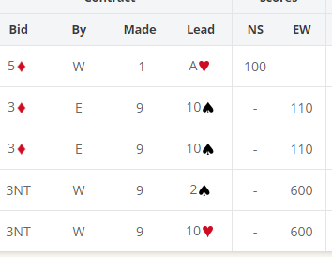
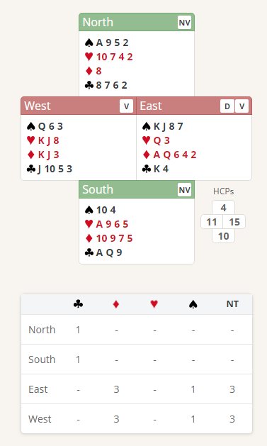

Suggested Bidding 1
N | E Dealer | S | W
 | 1D | Pass | 2NT
Pass | 3NT | All Pass

- Easts bid of 1 Diamond shows 12-19 points and at Least 4 Diamonds.
- Wests reply of 2 No Trumps shows 10-12 points and no 4 card major (A bid of 1 Spade or Heart promises 6+ points and a 4 card suit ) Note a bid of 1 No trump specifically says 6-9 Points (limit Bid)
- East with 15 points now knows that there is at least 25 points, so game is on so bids 3 No Trumps

Suggested Lead from North 2 Spades (signal to south to return the lead) You can lead away from an Ace in No Trumps ( Leading the Ace sets up 3 spades tricks for EW)

EW should lose the 3 Aces and the Q Clubs

Further notes about responses when the responder bids notrumps are at http://www.nzbridge.co.nz/user/inline/1639/NZB%20Beginner%2003A%20-%20Student%20Notes.pdf

Thursday Bidding Tips 6 Board 2 played on 31/5/2018 Junior Championships
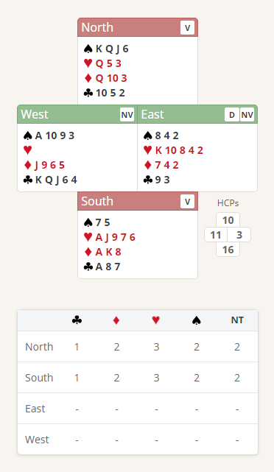
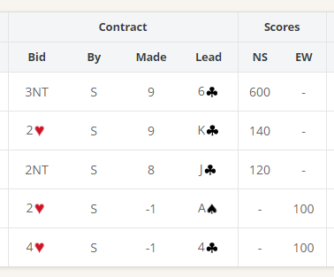

Suggested Bidding 1
N | E Dealer | S | W
 | Pass | 1H | 2C
2S | Pass | 3H | Pass
4H | All Pass

- Souths bid of 1 Heart shows 12-19 points and at Least 4 Hearts
- Wests overcall bid of 2 Clubs shows 10 plus points and 5 clubs.
- Norths reply of 2 Spades shows 10 plus points and 4 Spades ( Bid a new suit at the two level)
- East with 3 points passes
- South with 16 points now knows that there is at least 26 points, so game is on so bids 3 Hearts to show the 5-card suit and 15-16 points
- North with 3 Hearts support bids 4 Hearts

Suggested Lead from North K Clubs (Top of a sequence promises at least the Queen below it)
NS should go one away due to the unbalanced hearts in EW
Further notes about responses when the responder has changed suit are at http://www.nzbridge.co.nz/user/inline/2341/NZB%20Beginner%2004A%20-%20Student%20Notes.pdf (Page 2 )

